Process of how to use Git
- Create a local folder (let’s say D:\Stratus\GitWorking)
- Open Git Bash under this folder
- Under the command line
  - git clone git@github.com:Stratus-UI-Implementation/spc-ui-implementation.git
  - cd spc-ui-implementation
  - git remote add stratus git@github.com:stratustech/spc-ui-implementation.git
  - git checkout master
  - git pull origin master
  - git pull stratus stratuscloud-Rel-1.5.1.0-PGSQL
  - git checkout –b SC-00001 (This is the task you work in JIRA)
- Then you can work on your code
- After you finish this task, go back to find the branch you are working on and click Git Bash to open the command line
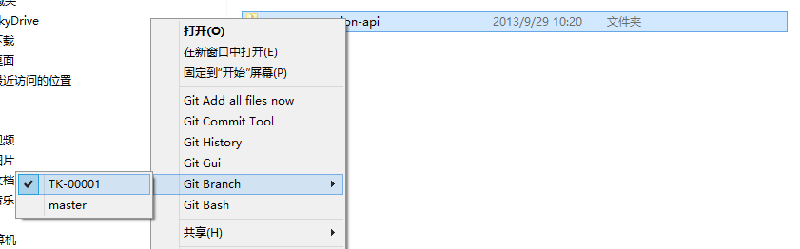
  - git gui
  - You will see a window opened, click the red cycle to move the changed files to be ready for commit
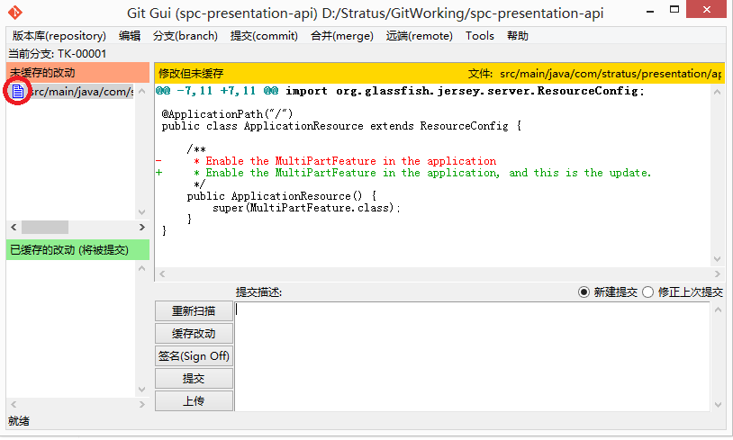
  - After you input the comments, you can submit by clicking the “提交”
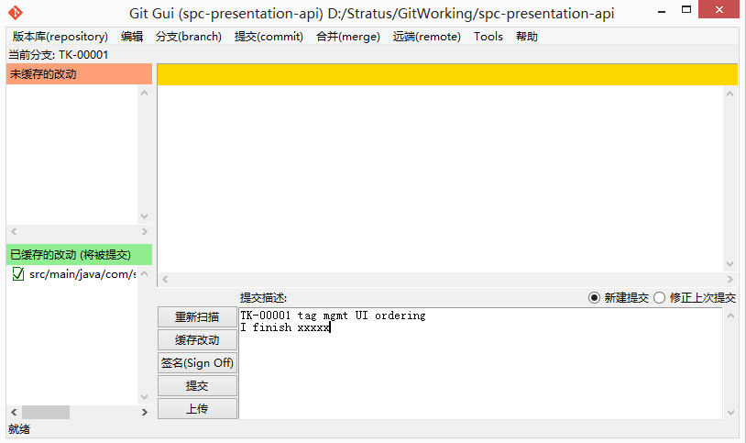
- Push to remote by clicking the “上传”
- Sending the pull request, go to git bash command line
  - git checkout master
  - git pull origin master
  - git pull stratus stratuscloud-Rel-1.5.1.0-PGSQL
  - git checkout -b SC-00001-for-merge
  - git merge --squash SC-00001
  - git gui and you will see
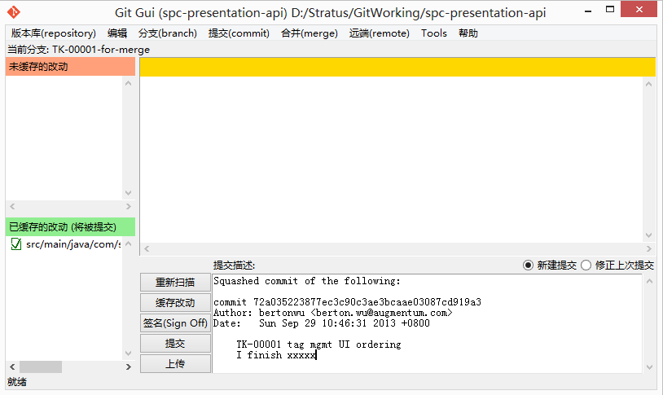
Click “提交” and “上传” to finish the process
- Go to www.github.com to find your branch and click “Compare & pull request”
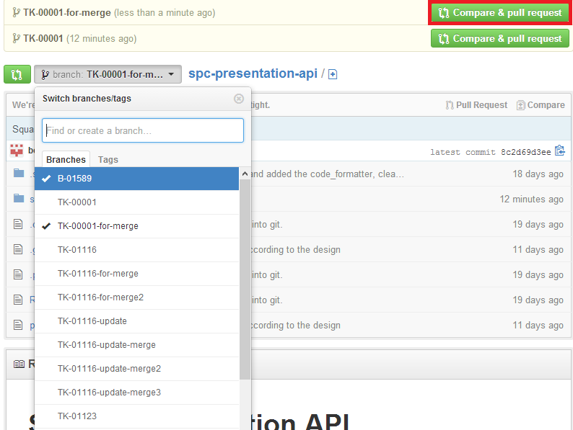
- Finally, info Berton to confirm the merge.

